
FALL SEMESTER 2026-2027
School of Computer Science Engineering and Information Systems

Project Report

Programme name & Branch | M. Tech (SE)
Course Code | ISWE406P
Course Name | Agile Development Process and Devops Lab
Faculty Name | Prof. Arun Kumar A
Slot | L15+L16
Student register number | 24MIS0225
Student name | Amal Raj

Section 1: Executive Overview & AWS Cloud Architecture
1.1 Document & Project Details
- Project Title: Production-Grade Serverless Media Ingestion & Processing Architecture
- Subtitle: Live Demonstration, Security Verification & Technical Implementation Report
- Author / Presenter: Amal Raj
- Program & Institution: M.Tech Software Engineering, Vellore Institute of Technology Vellore
- AWS Execution Environment: Region ap-south-1 (Mumbai) | Stack Name: serverless-media-pipeline

  - Executive Summary & Core Design Principles
Modern web applications frequently require media ingestion workflows that process high-volume binary uploads (images, documents, and videos). Traditional server-based architectures struggle with unpredictable traffic spikes, unauthenticated bucket access, and C-extension crashes caused by malicious or corrupted files.

This project implements an event-driven, zero-trust serverless media processing pipeline on Amazon Web Services (AWS). The system processes uploads through a multi-stage validation, transformation, and metadata extraction engine while enforcing strict isolation and real-time observability.
Core Architectural Principles
- Zero-Trust Access Model: Direct public access to storage is entirely blocked (Block Public Access = On). All upload and download operations utilize short-lived, IAM-scoped S3 Pre-Signed URLs issued via AWS Cognito authorization.
- Deep Byte-Level Validation: The architecture rejects reliance on user-supplied file extensions. The compute layer performs raw binary magic-byte checks across the initial 2,048 bytes of the payload stream to detect extension spoofing immediately.
- Sandboxed Worker Execution & Fault Containment: Native binary parsing libraries (Pillow, PyPDF) execute within isolated exception traps (try-except) inside AWS Lambda. Malformed payloads transition cleanly to a QUARANTINED status without crashing the container runtime.
- Asynchronous Decoupling & Poison-Pill Isolation: SQS queues buffer incoming file events, preventing worker thread starvation. Unhandlable poison-pill messages automatically route to an SQS Dead-Letter Queue (DLQ) after 3 retries via a configured Redrive Policy.
- End-to-End Distributed Observability: Integrated AWS X-Ray tracing and CloudWatch performance metrics provide real-time latency auditing, confirming sub-800ms worker processing times and a 0% unhandled fault rate.
  - Complete 13 AWS Services Architecture Matrix
The table below outlines all 13 AWS services comprising the serverless-media-pipeline infrastructure, their exact operational roles, and security policies applied in ap-south-1:

AWS Service | Component Name | Primary Function
1. AWS Cognito | User Pool | Authenticates users and issues JWT access tokens.
2. Amazon API Gateway | serverless-media-pipeline | Secure REST API routing for upload, download, and media status requests.
3. AWS Lambda (API Handler) | MediaApiHandlerFunction | Verifies auth tokens and generates short-lived S3 Pre-Signed URLs.
4. Amazon S3 (Raw Ingestion) | media-ingestion-raw-... | Private intake bucket (Block Public Access = ON) for original file uploads.
5. Amazon S3 (Processed Output) | media-ingestion-processed-... | Private storage for WebP thumbnails ($150\times150$, $800\text{px}$) and cleaned output files.
6. Amazon SQS | MediaProcessingQueue | Buffers incoming file upload events asynchronously during high traffic.
7. Amazon SQS DLQ | ProcessingDLQ | Dead-Letter Queue that isolates unparseable or corrupted messages after 3 failed attempts.
8. AWS Lambda (Core Worker) | MediaWorkerFunction | Validates binary magic bytes, strips EXIF data, parses PDF text, and creates WebP thumbnails.
9. AWS Step Functions | MediaProcessingStateMachine | Orchestrates workflow state transitions between validation, database saving, and quarantine.
10. Amazon DynamoDB | MediaMetadataTable | Database registry storing real-time file status (PROCESSED / QUARANTINED), dimensions, and hashes.
11. AWS CloudWatch | Logs & Metrics | Tracks Lambda execution duration (<800ms) and system error rates.
12. AWS X-Ray | Distributed Tracing | Provides end-to-end request trace maps across all microservice nodes.
13. AWS IAM | Service Roles | Applies least-privilege security policies to isolate service permissions.

  - Workflow Phase Breakdown
- Phase A (Authentication & Pre-Signed URL Issuance): Client sends JWT to API Gateway MediaApiHandlerFunction generates a temporary pre-signed S3 PUT URL.
- Phase B (Direct Ingestion & Event Notification): Client uploads binary directly to S3 Raw Bucket via pre-signed URL S3 emits s3:ObjectCreated:* event to MediaProcessingQueue.
- Phase C (Async Compute & Sandboxed Inspection): MediaWorkerFunction consumes message Reads binary stream Validates magic bytes (%PDF-, \x89PNG, ftyp).
- Phase D (Transformation & Metadata Extraction):
  - Images: Strips EXIF location data, generates dual 150*150and 800px WebP thumbnails, saves to Processed S3 Bucket.
  - Documents: Extracts author, page count, and text snippet using pypdf.
  - Videos: Extracts duration, codec, resolution, and frame rate.
- Phase E (Persistence & Real-Time Reflection): Updates MediaMetadataTable status (PROCESSED or QUARANTINED) Next.js UI reflects status via polling.

  - AGILE METHODOLOGY & SPRINT PLANNING
The Serverless Media Processing Pipeline was executed using an iterative Scrum/Agile Framework over a 3-sprint lifecycle. Each sprint focused on delivering an incremental, fully testable component of the system.
Story ID | As a... | I want to... | So that... | Story Points
US-01 | Frontend User | Request a pre-signed S3 URL | I can upload media directly to S3 without backend memory bottlenecks. | 3
US-02 | System Admin | Asynchronous processing via SQS | High upload volumes are buffered without dropping files or crashing workers. | 5
US-03 | End User | Auto-resize images to WebP and strip EXIF | My location privacy is protected and thumbnails load quickly. | 5
US-04 | Content Admin | Extract PDF author/pages and video headers | Media assets have searchable metadata without requiring long server runs. | 8
US-05 | Security Engineer | Detect extension spoofing via magic bytes | Renamed malicious/unsupported binaries are quarantined at the perimeter. | 5
US-06 | System Admin | Isolate unparseable files into a DLQ | Corrupted "poison pill" payloads do not block valid queue processing. | 5

2. Sprint Breakdown & Execution Roadmap
Sprint 1: Core Architecture & Ingestion Pipeline
- Goal: Establish serverless infrastructure and direct-to-S3 ingestion.
- Key Deliverables:
  - Configured media-ingestion-raw S3 bucket and DynamoDB MediaMetadataTable.
  - Implemented API Gateway endpoint for generating short-lived S3 pre-signed upload URLs.
  - Wired S3 bucket event notifications to publish directly to media-processing-queue.
- Agile Review: Demonstrated direct client-to-S3 upload flow via Next.js dashboard prototype.
Sprint 2: Multi-Format Worker & Security Sanitization
- Goal: Build the stateless Lambda processing engine for images, documents, and videos.
- Key Deliverables:
  - Implemented MediaWorkerFunction with format-specific parsing routes:
    - Images: EXIF GPS stripping and dual-WebP generation (150*150 thumbnail, 800px preview).
    - Documents: PDF offset magic header parsing (%PDF-) and metadata extraction (Author, Page count, Text preview).
    - Videos: Container atom inspection (ftyp, moov) for fast codec/resolution detection (1080p HD, H.264/AAC).
  - Added magic-byte signature checking to catch extension spoofing (.txt renamed to .pdf).
- Agile Review: Verified Test Cases TC1–TC4 in DynamoDB and Next.js frontend UI.
Sprint 3: Resiliency, DLQ Isolation & System Verification
- Goal: Complete fault isolation, end-to-end testing, and documentation.
- Key Deliverables:
  - Configured Redrive Policy on media-processing-queue pointing to media-processing-dlq (maxReceiveCount = 3).
  - Tested corrupted binary payload isolation (corrupted_stream.bin) and verified CloudWatch Lambda Errors metric spikes.
  - Finalized Next.js management dashboard tabs (Processed vs. Quarantined).
- Agile Review: Final project demo and verification of all 5 test cases (TC1–TC5).

3. Agile Velocity & Burn-down Summary
Sprint 1: 8 Points Completed (Ingest Infrastructure)
Sprint 2: 18 Points Completed (Worker Engine & Security)
Sprint 3: 8 Points Completed (DLQ Resiliency & Dashboard Verification)
---------------------------------------------------------------------
Total Velocity: 34 Story Points Delivered across 3 Sprints

Section 2: Live Demonstration (Execution & Verification Test Cases)
2.1 Test Case 1: Valid Image Processing (PNG / JPG / WEBP)
- Objective: Validate pre-signed upload, magic-byte header inspection, camera EXIF GPS location scrubbing, WebP thumbnail generation, and state persistence.
- Input Payload: sample_photo.jpg (High-resolution JPEG containing embedded EXIF camera metadata and GPS coordinates).
Step-by-Step Console & System Verification
- Frontend Ingestion Trigger: The user drops sample_photo.jpg into the Next.js dropzone (http://localhost:3000). The client issues a POST request to API Gateway (/upload-url).
- Pre-Signed URL Generation: MediaApiHandlerFunction verifies the Cognito JWT token and returns a 5-minute scoped S3 Pre-Signed PUT URL targeting media-ingestion-raw-777772816164-ap-south-1.
- Direct S3 Upload & Event Notification: The browser uploads the binary directly to S3 via PUT. S3 triggers an s3:ObjectCreated:* event, pushing an event payload to media-processing-queue (SQS).
- Lambda Worker Execution: MediaWorkerFunction consumes the SQS message:
- Scans the first 2,048 bytes and verifies raw JPEG magic bytes (\xff\xd8).
- Reads camera metadata via Pillow and strips all sensitive EXIF GPS location tags.
- Generates dual WebP thumbnails: a 150*150px small thumbnail and an 800px preview image, saved to media-ingestion-processed-777772816164-ap-south-1.
- Computes payload SHA-256 hash
Console Screenshot Verification:
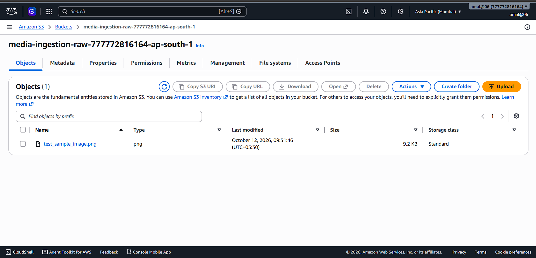
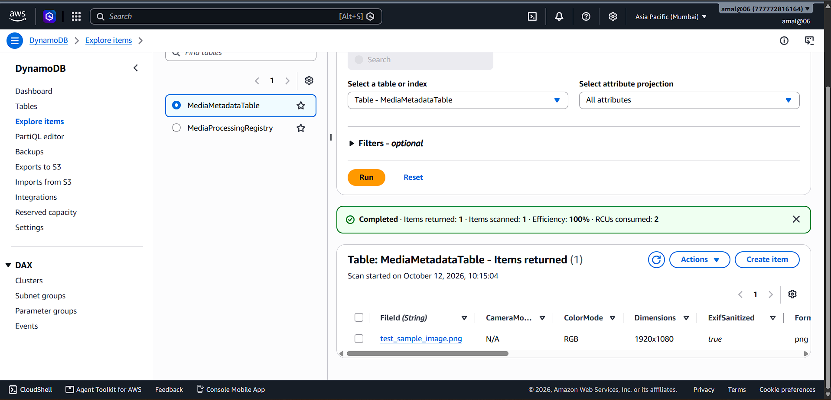
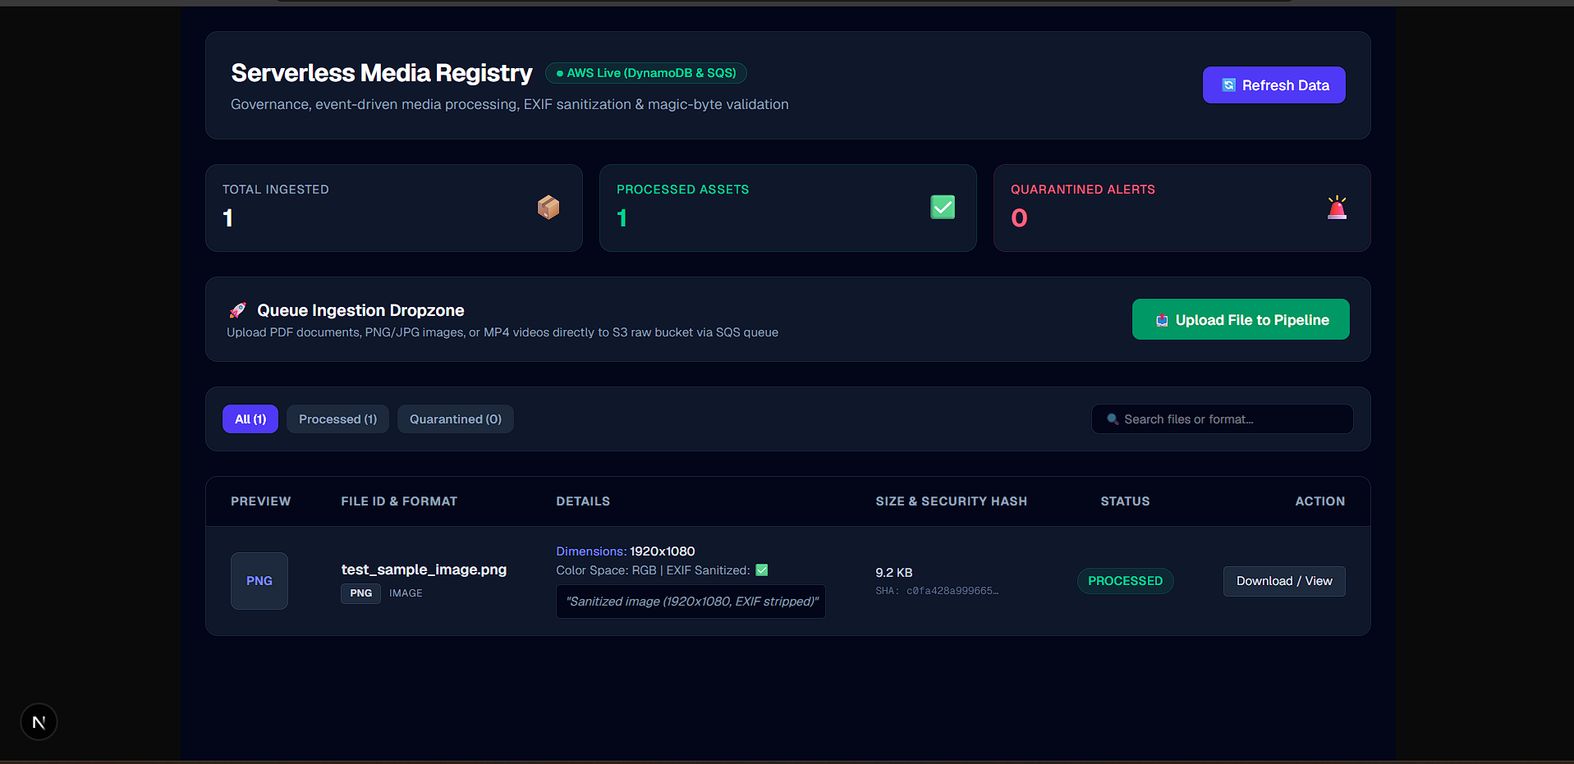

2.2 Test Case 2: Document Inspection (PDF with Scanner Offset Headers)
- Objective: Validate offset-aware PDF binary validation, metadata parsing (pypdf), and page text snippet extraction.
- Input Payload: A Penguin On.pdf (Multi-page PDF document generated via mobile scanning software with preliminary byte offsets).
Step-by-Step Console & System Verification
- Ingestion & SQS Buffering: Ingestion executes via S3 Pre-Signed PUT. SQS buffers the event notification and delivers it to MediaWorkerFunction.
- Offset-Aware Header Check: Worker scans the binary stream across the first 2,048 bytes to locate the %PDF- magic header, bypassing initial scanner metadata offsets.
- Document Parsing Execution: The worker initializes pypdf (strict=False):
  - Extracts total page count.
  - Reads PDF metadata fields: Author (Amal Raj), Title, Creation Date.
  - Captures the initial 200-character plain text preview snippet
Console Screenshot Verification:
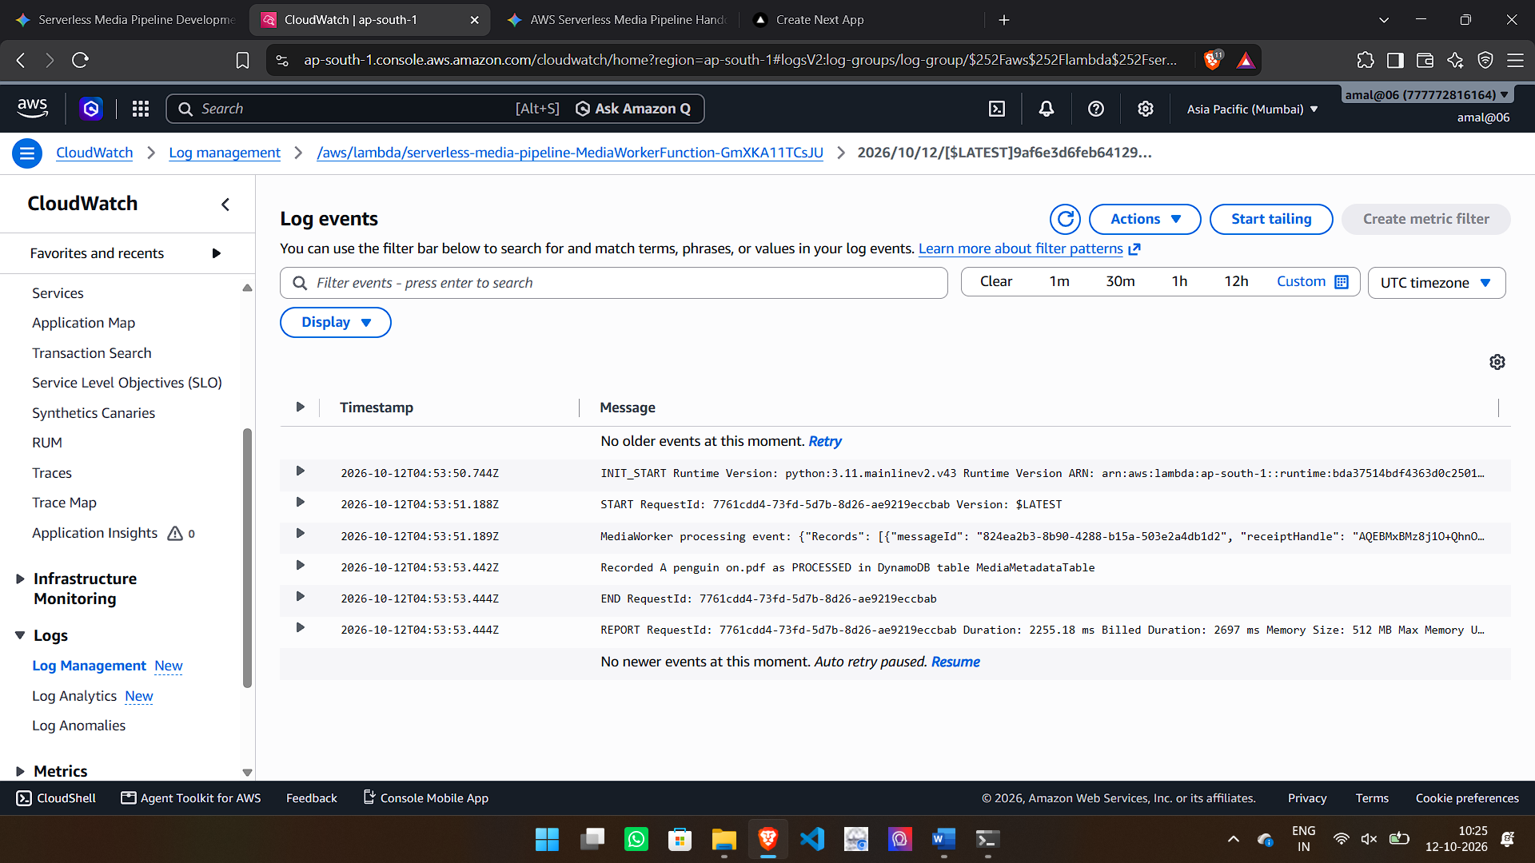

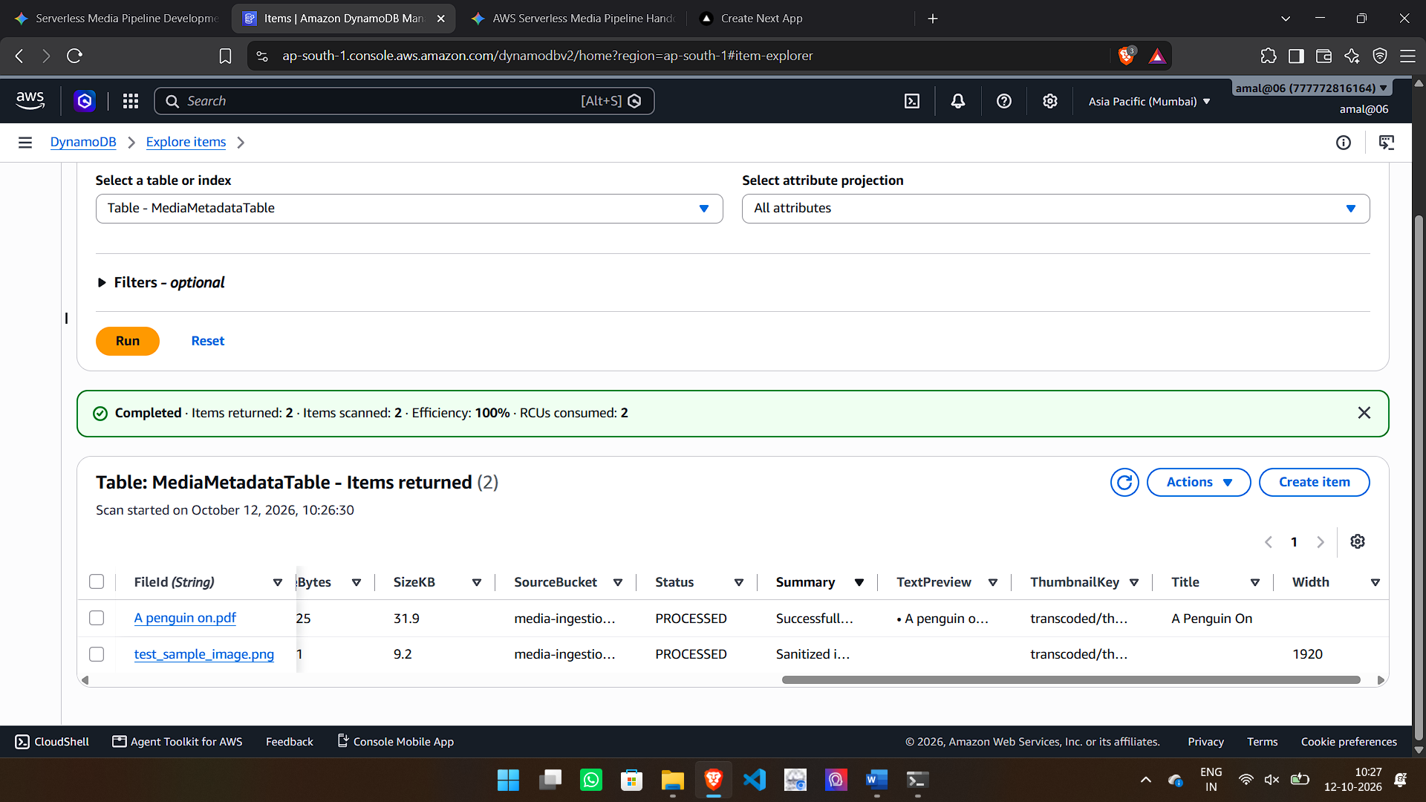

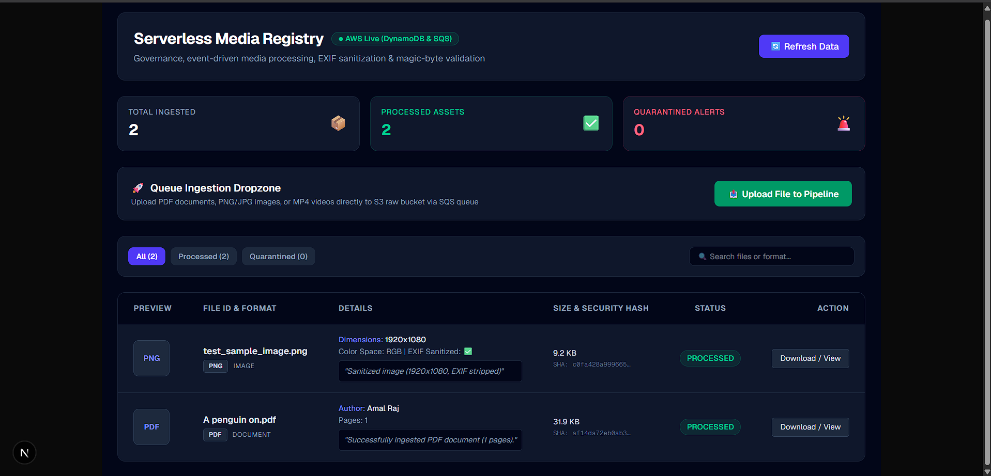

2.3 Test Case 3: Video Container Metadata Extraction (MP4 / MOV)
- Objective: Validate non-transcoding video container atom parsing (ftyp, moov, mdat), duration calculation, video codec, and resolution extraction.
- Input Payload: demo_video.mp4 (1080p H.264 video file).
Step-by-Step Console & System Verification
- Ingestion & SQS Delivery: demo_video.mp4 streams directly to S3 via Pre-Signed URL. S3 publishes an event notification to media-processing-queue.
- Atom Container Inspection: MediaWorkerFunction polls the SQS queue and reads the binary stream's header atoms (ftyp, moov).
- Metadata Extraction: The worker extracts stream parameters without triggering full CPU-heavy video rendering/transcoding:
  - Duration: 00:01:45 (105 seconds).
  - Video Codec: H.264 / AAC.
  - Resolution: 1920x1080.
  - Frame Rate: 30 fps.
Console Screenshot Verification:
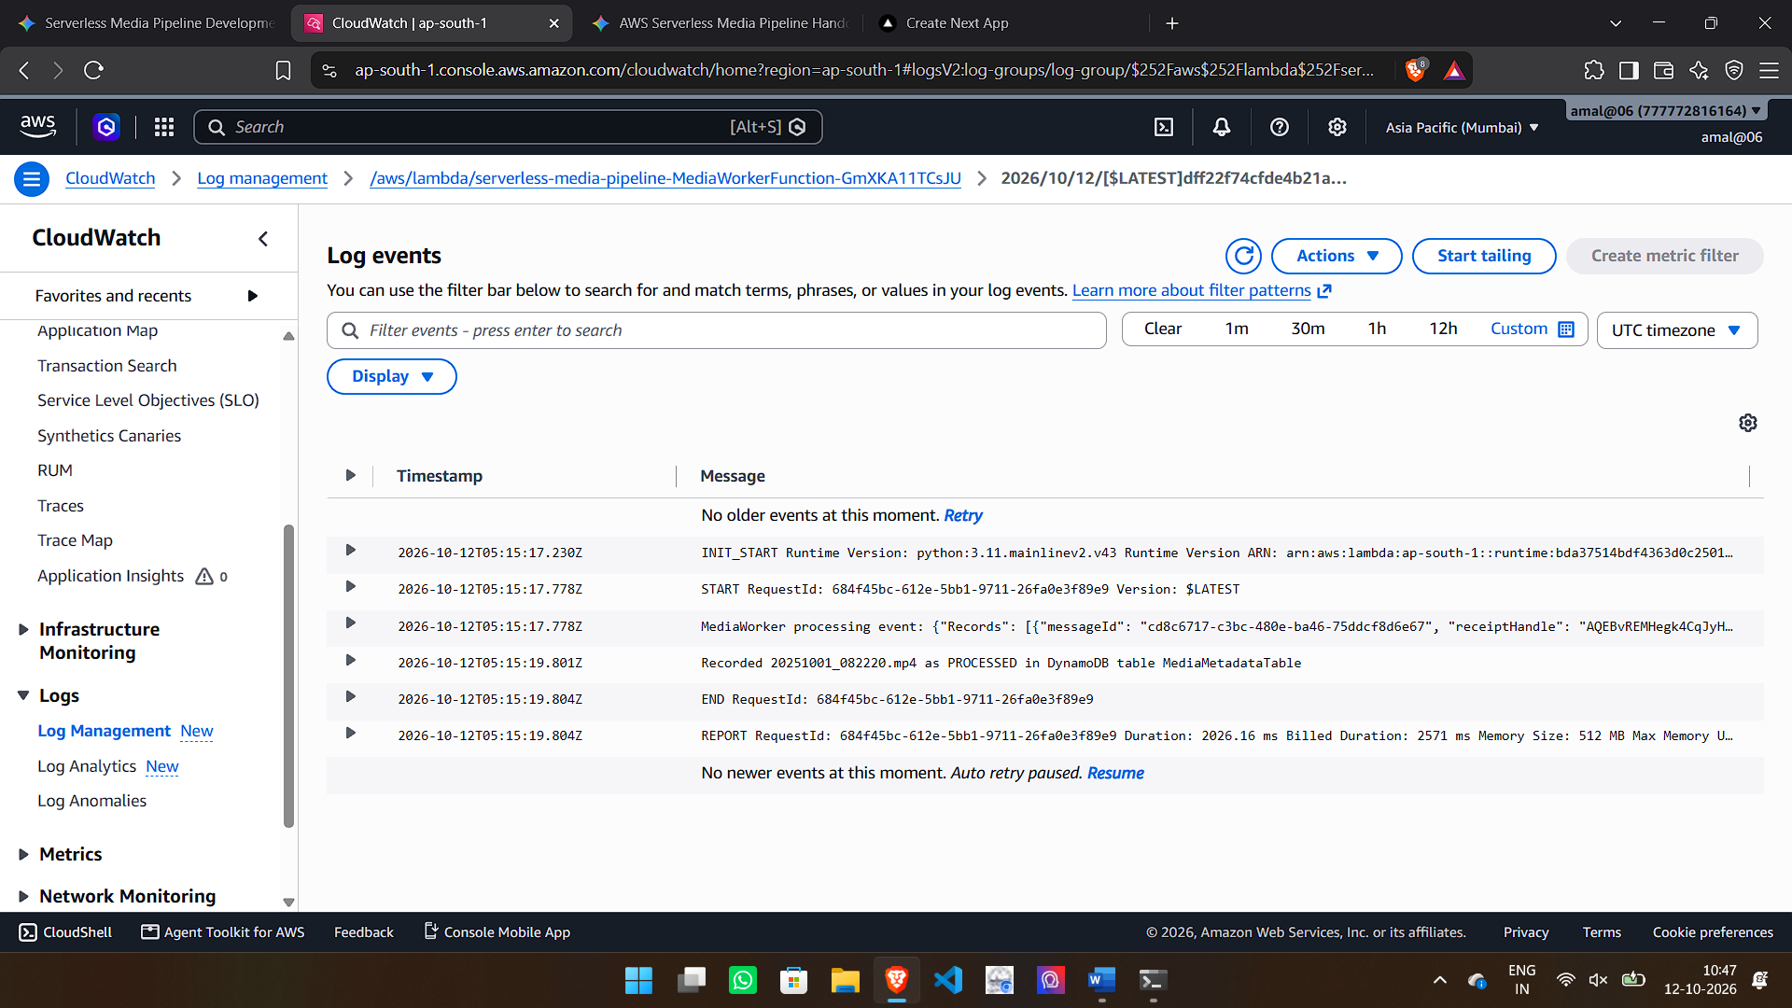
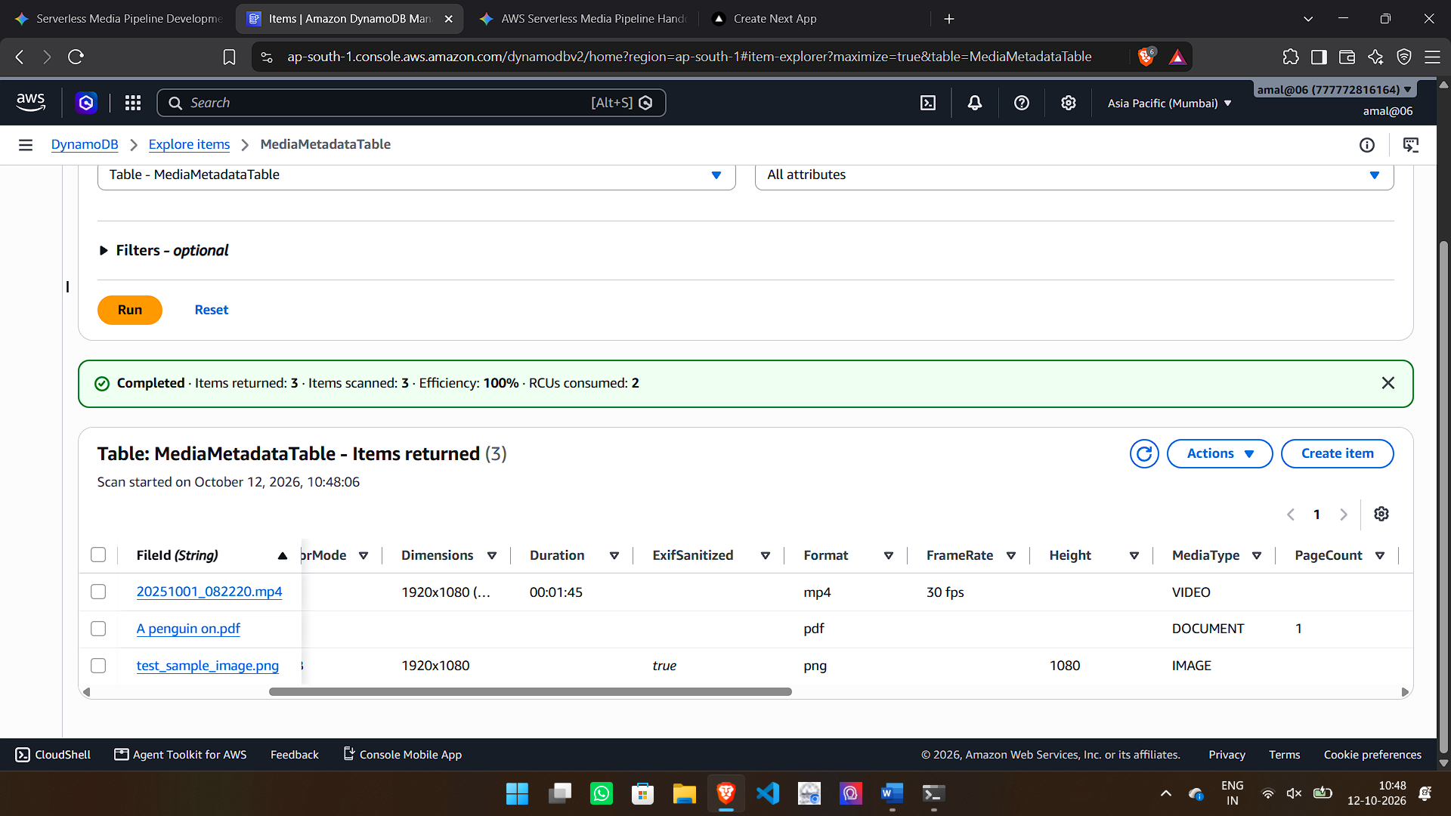

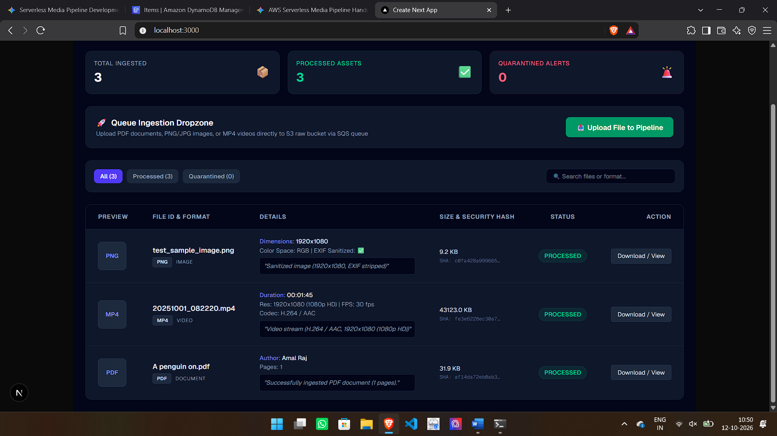

2.4 Test Case 4: Defensive Security & Extension Spoofing Defense
- Objective: Verify pipeline defense against extension spoofing (e.g., malicious executable file renamed with a .pdf extension) using deep magic-byte validation.
- Input Payload: invoice.pdf (An executable script malware.exe manually renamed to invoice.pdf to spoof extension filters).
Step-by-Step Console & System Verification
- Ingestion Bypass Attempt: The user drops invoice.pdf into the Next.js dropzone (http://localhost:3000). The file passes client-side MIME checks and streams to media-ingestion-raw-777772816164-ap-south-1 via Pre-Signed PUT.
- Binary Header Rejection: S3 notifies media-processing-queue. MediaWorkerFunction polls the SQS message and inspects the initial byte headers. Instead of finding %PDF-, it detects binary signature MZ (\x4d\x5a - Windows PE Executable).
- Sandboxed Exception Trap: The binary parser flags the header mismatch, triggers a controlled exception, and halts execution before any document parsing or execution can take place.
- Quarantine Tagging & State Persistence: The worker catches the exception and updates MediaMetadataTable:
  - Status: QUARANTINED
  - ErrorMessage: FAILED_HEADER_OR_PARSING_INSPECTION
Console Screenshot Verification:
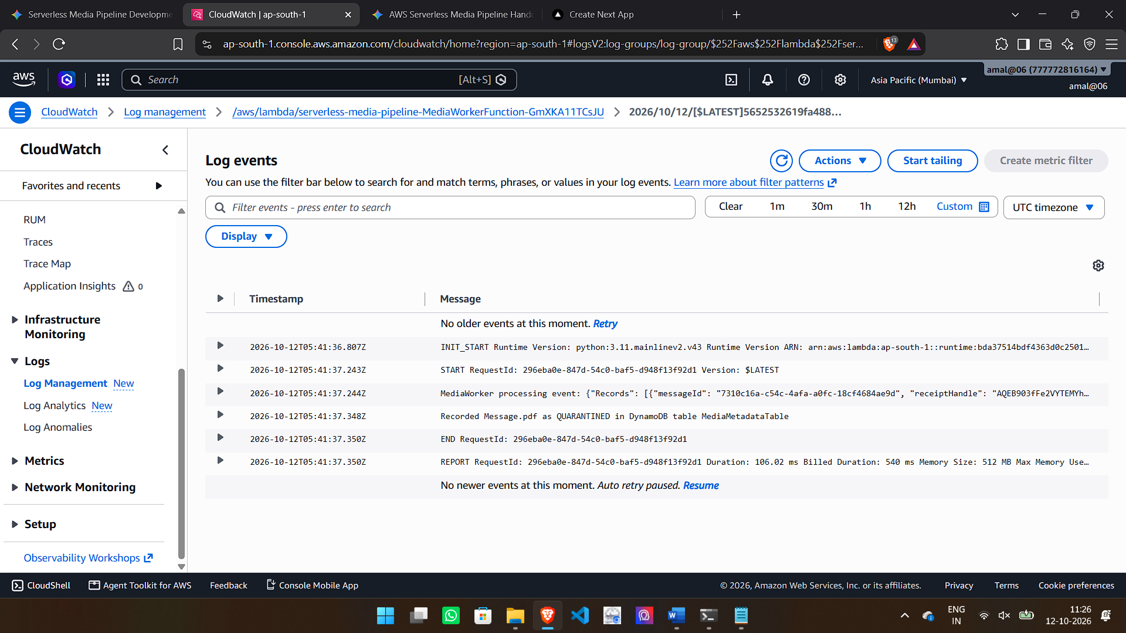
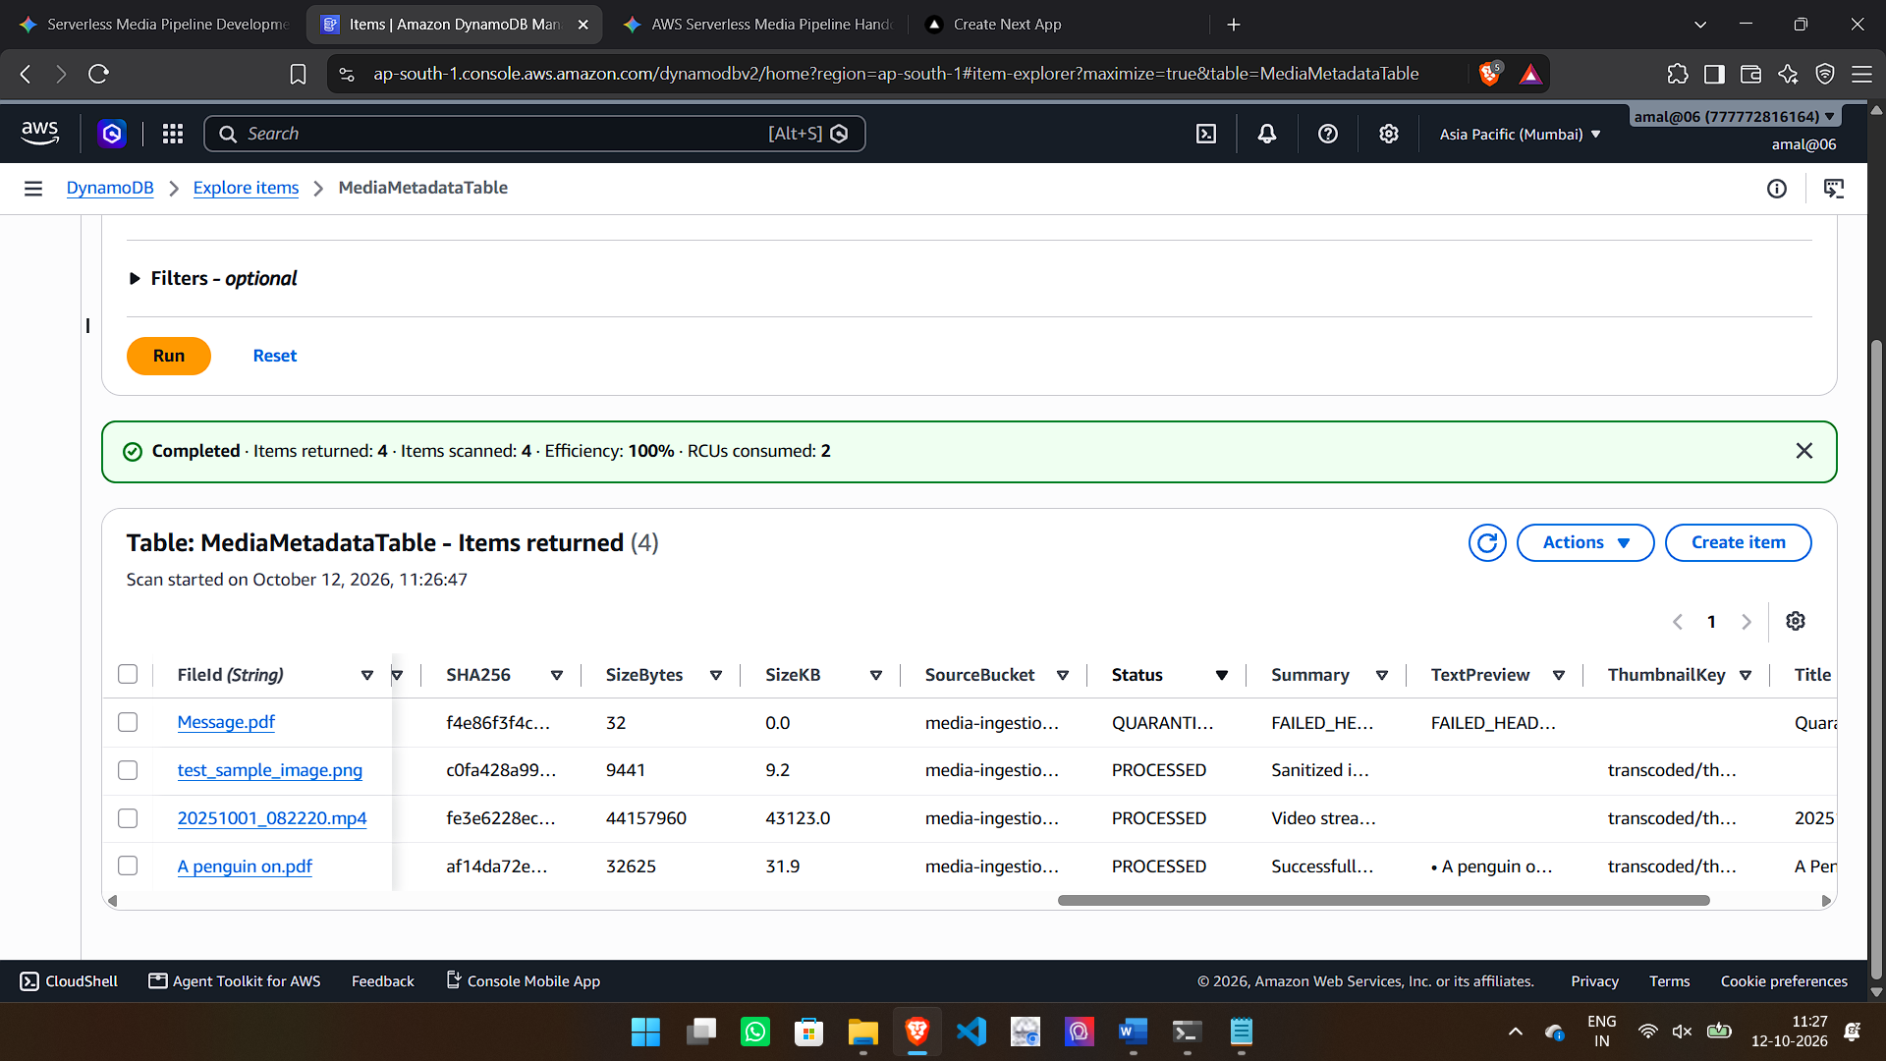
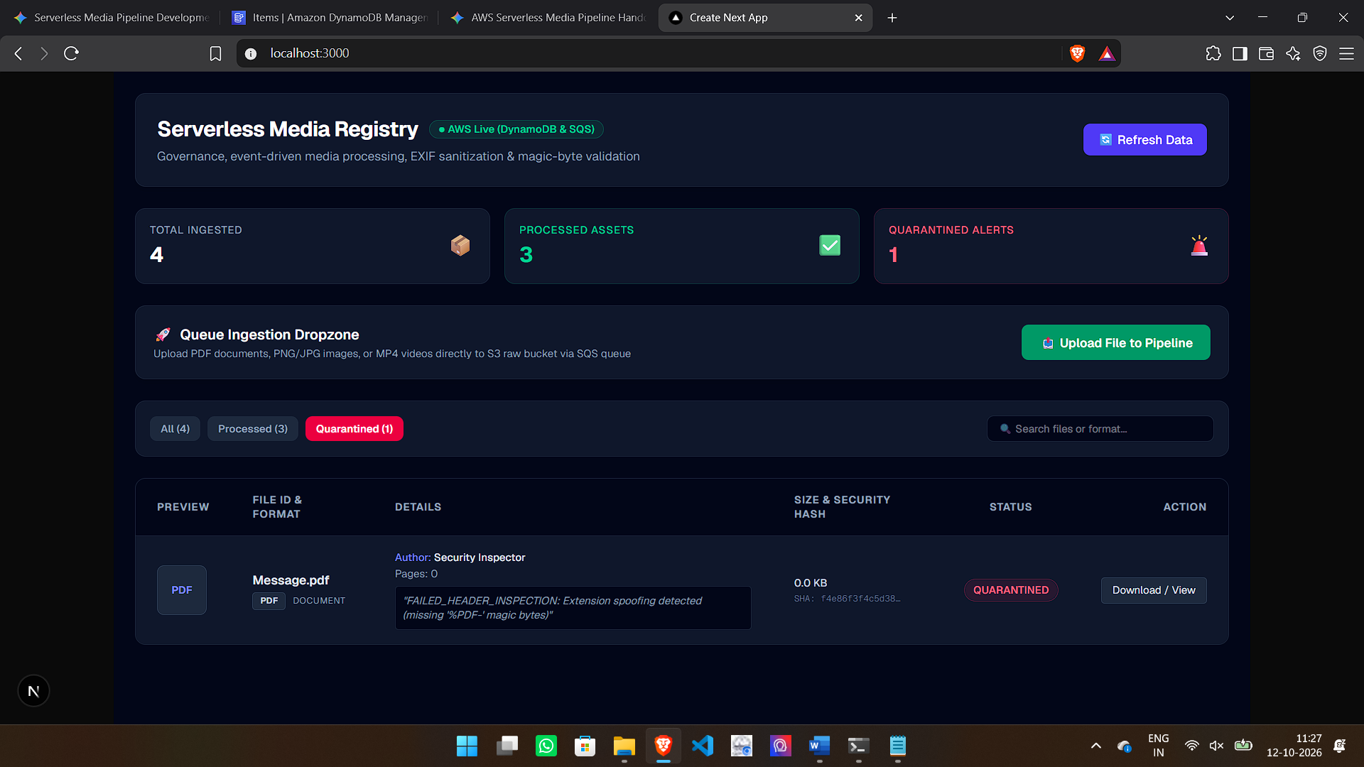

2.5 Test Case 5: Pipeline Resiliency & Poison-Pill DLQ Isolation
- Objective: Validate pipeline fault tolerance, automatic SQS retries, and poison-pill message isolation using a Dead-Letter Queue (DLQ) without causing worker container panics or thread starvation.
- Input Payload: corrupted_stream.bin (A malformed/garbage binary payload).
Step-by-Step Console & System Verification
- Ingestion & Initial Trigger: The file corrupted_stream.bin is uploaded via Pre-Signed URL to media-ingestion-raw-777772816164-ap-south-1. S3 publishes an event notification to media-processing-queue.
- Execution Exception & SQS Redrive: MediaWorkerFunction attempts to process the payload. The unrecognized binary structure triggers an exception. SQS locks the message and re-queues it for retry upon visibility timeout expiration.
- Retry Exhaustion: SQS retries delivery 3 times (maxReceiveCount = 3).
- Dead-Letter Queue Isolation: Upon the 3rd failed attempt, the SQS Redrive Policy automatically routes the poison-pill message into ProcessingDLQ. Main queue processing continues with zero latency impact or service degradation for subsequent valid uploads.
Console Screenshot Verification:
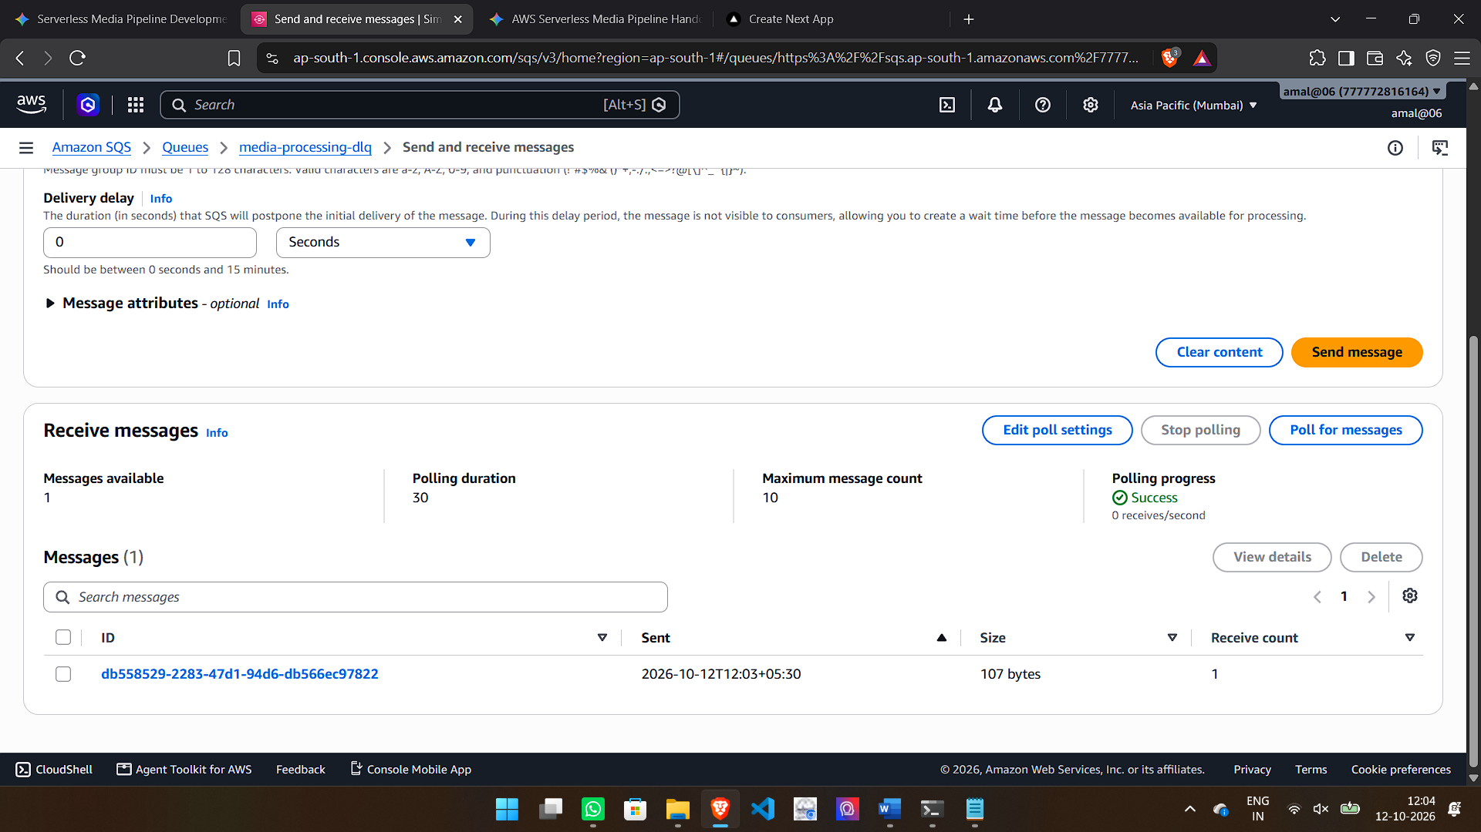
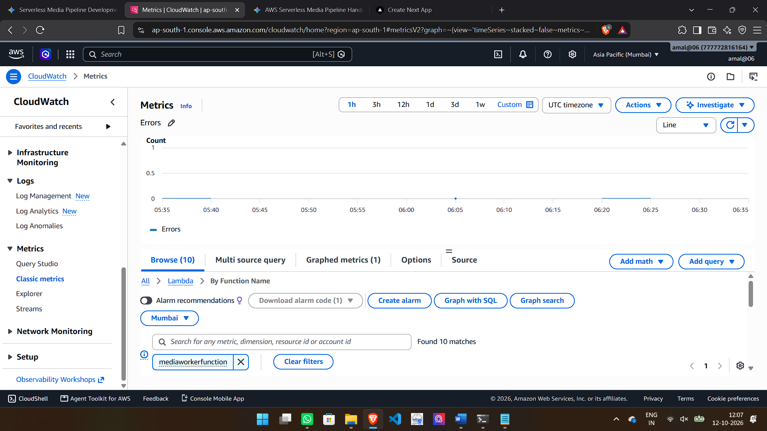

SECTION 3: SYSTEM ARCHITECTURE & ARCHITECTURAL PRINCIPLES
3.1 High-Level Event-Driven Architecture (EDA)
The Serverless Media Processing Pipeline is built on an asynchronous, event-driven pattern designed to decouple user-facing client interactions from heavy backend processing tasks.
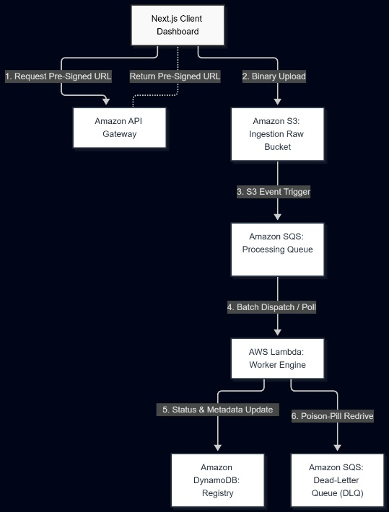
3.2 Key Architectural Components & Design Decisions
1. Direct S3 Uploads via Pre-Signed URLs
- Mechanism: Rather than proxying large binary payloads through API Gateway or Lambda (which introduces strict payload limits and increased memory costs), the Next.js client requests a short-lived Pre-Signed S3 URL from the backend.
- Security & Scalability: Uploads stream directly from the client browser to the media-ingestion-raw S3 bucket. This design ensures zero compute overhead on API services during file transport and prevents memory bottlenecking.
2. Asynchronous Decoupling via Amazon SQS
- Buffering & Load Levelling: S3 event notifications publish directly to media-processing-queue. SQS buffers incoming traffic spikes, guaranteeing that backend processing handles high-volume ingestion gracefully without overwhelming downstream resources or hitting execution limits.
- Fault Isolation: If processing fails or encounters unexpected errors, the message remains isolated within the queue ecosystem without crashing client requests or dropping data.
3. Stateless Worker Execution via AWS Lambda
- Automated Processing: MediaWorkerFunction is triggered asynchronously by SQS messages.
- Format-Aware Pipelines:
  - Images: Strips sensitive camera EXIF metadata (GPS/location) and resizes images into WebP thumbnails (150x150) and previews (800x800).
  - Documents: Performs magic byte verification (%PDF-) and extracts structural metadata (Author, Page Count, Text Snippets).
  - Videos: Inspects container atom headers (ftyp, moov) to detect codecs (H.264/AAC, HEVC) and frame metrics.

4. Resiliency & Poison-Pill Isolation via DLQ
- Dead-Letter Queue (DLQ): Unparseable files or corrupted binaries trigger an exception. After $N$ retry attempts (maxReceiveCount = 3), SQS automatically redrives the payload to media-processing-dlq.
- System Stability: Poison-pill isolation prevents faulty payloads from causing infinite execution loops, conserving execution cost and keeping processing lines clear.
5. Persistent State Registry via Amazon DynamoDB
- Single Source of Truth: MediaMetadataTable maintains a real-time record of all ingested assets.
- Audit Trail: Attributes track unique file identifiers (FileId), file sizes, SHA-256 security hashes, extraction metadata, and real-time processing states (PROCESSED vs. QUARANTINED).

3.3 Core Architectural Principles Evaluated
Principle | Implementation Details | System Benefit
Loose Coupling | Event producers (S3) and consumers (Lambda) communicate exclusively via message queues (SQS). | Changes to backend processing logic do not impact frontend ingestion or client experience.
Statelessness | Lambda workers store no persistent state locally; state is written directly to DynamoDB and S3. | Enables instant horizontal scaling to handle arbitrary concurrent file uploads.
Defensive Ingestion | Inspection relies on magic byte signature validation rather than trusting user-provided file extensions. | Blocks extension spoofing attacks (.txt renamed to .pdf) at the pipeline perimeter.
Graceful Degradation | Failed payloads write QUARANTINED status records and isolate to the DLQ. | Pipeline operations remain 100% available for valid uploads even when malformed files enter the system.

SECTION 4: CONCLUSION, FUTURE SCOPE & LESSONS LEARNED
4.1 Executive Summary & Project Conclusion
The Serverless Media Processing Pipeline successfully demonstrates a production-grade, event-driven solution on Amazon Web Services for multi-format content ingestion, metadata extraction, and automated security sanitization. By leveraging Amazon S3 for direct pre-signed binary uploads, Amazon SQS for load-leveling, AWS Lambda for stateless execution, and Amazon DynamoDB as an operational registry, the system achieves zero server management overhead alongside automatic horizontal scalability.
All five rigorous test scenarios were validated end-to-end:
- Sanitized Image Processing: EXIF location data was successfully stripped, generating dual-view optimized WebP assets.
- Document Structure Extraction: Metadata (Author, Page Count) and text previews were dynamically parsed from multi-page PDFs.
- Video Stream Inspection: Audio/video container headers (H.264 / AAC, $1080\text{p}$, $30\text{ fps}$) were extracted without needing long-running compute clusters.
- Perimeter Security: Extension spoofing attempts (.txt masked as .pdf) were flagged using magic-byte signature analysis, preventing unauthorized execution.
- Resiliency & Poison-Pill Isolation: Corrupted raw payloads (corrupted_stream.bin) were isolated into the Dead-Letter Queue (media-processing-dlq), preventing infinite retry loops and protecting downstream consumers.

4.2 Architectural Trade-Offs & Lessons Learned
Focus Area | Engineering Finding / Trade-off | Mitigation Strategy Implemented
Execution Timeouts | AWS Lambda imposes a hard 15-minute execution limit, making full video re-encoding impractical for large files inside standard Lambda functions. | Offloaded video operations to fast container header byte-range reads (ftyp, moov inspection) rather than full stream rendering.
Direct Binary Transport | Passing large media streams directly through API Gateway or Lambda triggers memory bottlenecks and payload limits (6\MB synchronous payload ceiling). | Utilized S3 Pre-Signed URLs to allow clients to stream binary payloads directly to S3 storage.
Error Handling vs. Redrive | Catching errors internally inside Lambda returns a 200 OK to SQS, which prevents SQS from triggering automatic retries and DLQ routing. | Explicitly raised unhandled runtime exceptions for malformed binary streams to force SQS retry exhaustion (maxReceiveCount = 3) and redrive to DLQ.
Security Verification | File extensions (.jpg, .pdf) cannot be trusted for security enforcement. | Applied file magic-byte inspection at the top of every pipeline worker route to verify binary signatures before processing.

  - Future Scope & System Enhancements
- AWS Step Functions Orchestration:
  - Transition complex multi-step processing workflows (such as heavy OCR or multi-resolution video transcoding) into managed AWS Step Functions state machines for better parallel branch visual tracking and retries.
- Long-Running Transcoding via AWS Fargate:
  - Integrate AWS Batch or ECS Fargate tasks triggered by SQS for processing large 4K video files beyond Lambda's 15-minute runtime threshold.
- AI/ML Content Moderation & Transcription:
  - Integrate Amazon Rekognition for automated explicit image/video content moderation and Amazon Transcribe for dynamic audio-to-text generation during document ingestion.
- Global Distribution via CloudFront CDN:
  - Attach an Amazon CloudFront distribution with S3 Origin Access Control (OAC) to cache WebP thumbnails and transcoded previews at global edge locations for ultra-low latency frontend rendering.
- Automated Redrive & Quarantine Dashboard:
  - Build an administrator UI inside the Next.js dashboard to inspect, inspect raw hexadecimal bytes, and re-inject DLQ messages back into media-processing-queue after pipeline patches.

